 | Job Description | February 2026

Role: Visitor Services Assistant – Retail, Admissions & Tours | Region: South & West
Reports to: Visitor Services Manager – Retail, Admissions & Tours | Pay Grade: Grade 1 - £27,976 pro rata, per annum
Location: The Mackintosh Tearooms - 217 Sauchiehall Street, Glasgow, G2 3EX | Type of Contract: Permanent, Part-Time 20 Hours Per Week.
Terms and conditions
The post is subject to the standard terms and conditions provided with the application pack and the following special terms also apply - hours of work = 40 per week on days and at times to suit the needs of the job and property opening hours (this will include regular weekend/public holiday duties and some evening work)

The Mackintosh Tearooms is the home of the original Willow Tea Rooms Building at 217 Sauchiehall Street. It was first opened by Miss Cranston in 1903 and designed by Charles Rennie Mackintosh in collaboration with his wife, Margaret Macdonald. Following a detailed restoration project in 2018, the building is now back to its former glory as a unique tearoom over three floors. It now includes additional event spaces, an exhibition, and a gift shop. In January 2024, The Mackintosh Tearooms was acquired by the National Trust for Scotland, and the Property is now under their care.

JOB PURPOSE

As a member of our front of house retail and visitor team, you will work in a fast-paced customer facing environment, providing exceptional customer service in the day to day retail operations and delivering guided tours, offering visitors a warm welcome and being passionate about delivering a memorable visitor experience in a setting that reflects our heritage.

Key Responsibilities
- Deliver a warm welcome to local, national and international visitors
- Knowledgeable about the product range and encouraging upselling of membership, tours, exhibition and tea rooms offer
- Provide excellent customer care
- Billing - Cash and Credit Card handling
- Adhere to all financial procedures to include till operations and cash reconciliation duties.
- Adhere to Health and Safety & Food Safety practises and guidelines
- Delivering and assisting with public and private guided tours, as well as exhibition events
- Upsell products within the property
- Assist with stock management duties, including stock counts and supporting regular stocktakes.
- Actively feedback visitor comments to line managers to improve offer, service and operation
- Help achieve sales targets and membership recruitment targets.
- Promote the National Trust for Scotland as a memberships organisation and the benefits of becoming a member to all visitors.

- Wear the correct uniform, name badges, or PPE as required.
- Undertake any other tasks that may be reasonable requested

REQUIRED QUALIFICATIONS, SKILLS, EXPERIENCE & KNOWLEDGE

Qualifications
- No formal qualifications are required
Essential Skills
- Some experience in the retail and tourism industry in a customer facing role
- Ability to work in a fast-paced environment
- Ability to work as part of a diverse team
- A willingness to share skills with others
- A great communicator with people

Desirable
- Familiar with EPOS systems
- A willingness to be cross trained, particularly in providing operational support, and in other departments
- A passion for storytelling
- Knowledge of Charles Rennie Mackintosh and fascinating history of the Tea Rooms
- A passion for Scotland & Glasgow’s heritage and a willingness to enthusiastically share this with our visitors

Organisational chart

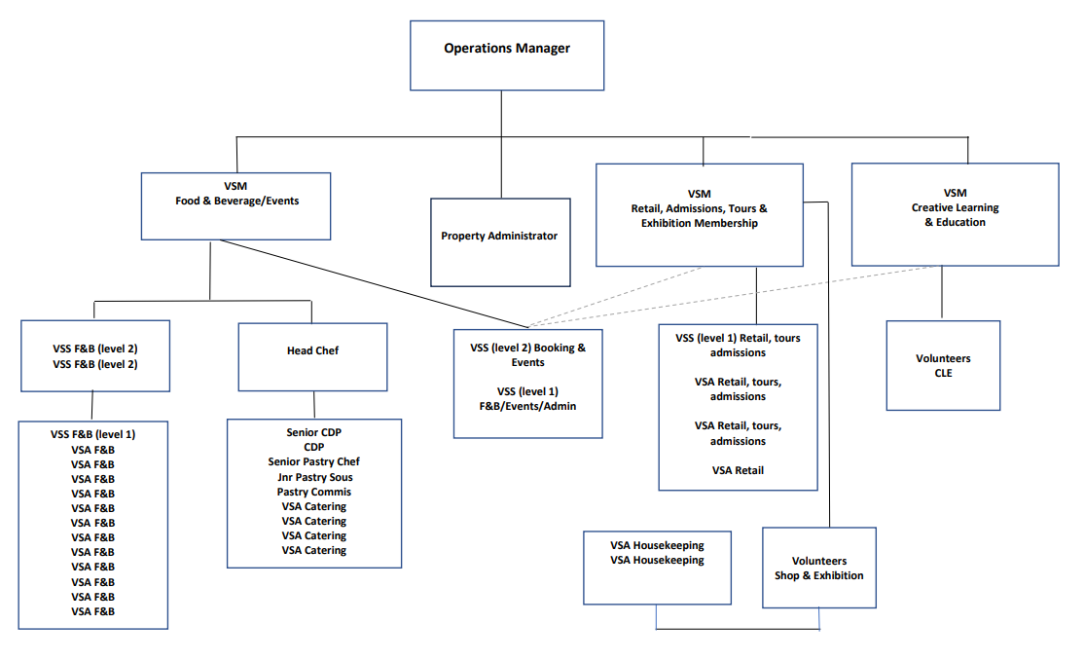

DIMENSIONS AND SCOPE OF JOB

Scale
- Retail and Visitor Centre

People Management
- N/A

Finance Management
- Adhere to the Trust’s financial procedures to include till operation and cash handling duties.
- Help achieve sales targets and membership recruitment targets
- Upsell products across the property
- Actively feedback visitor comments to line managers to improve offer, service and operations,

Tools / equipment / systems
- EPOS till system for retail sales and ticket sales
- Clock in/clock out on payroll app
- PeopleXD
- Eventbrite
- ResDiary
- TouchOffice

Health & Safety
- Adhere to Health & Safety procedures and legislation in liaison with your department manager.

Example key performance indicators and targets
- To contribute the overall revenue of the retail and visitor centre through excellent service delivery and upselling.
- To contribute to achieving a high scoring Mystery Shop review
- Good attendance record
- Positive customer feedback/reviews
- Adhere to and follow the Trust’s policies and procedures and training requirements with a positive attitude.

The Purpose, Context, Key Responsibilities, and Person Specification reflect the requirements of the job at the time of issue. The Trust reserves the right to amend these with appropriate consultation and/or request the post-holder to undertake any activities that it believes to be reasonable within the broad scope of the job or his/her general abilities.

HOW TO APPLY

Interested applicants should forward their Curriculum Vitae (CV) or an Application Form to the People Services Department (Applications) by email via workforus@nts.org.uk by Thursday 12th March 2026.

Please ensure your CV includes your full name and contact details, the CV file sent to us should be titled your first initial and surname. When submitting your CV please state the position and job location of the vacancy you are applying for in the subject title or body of your email: For example, "VSA Retail, Admissions & Tours – Mackintosh Tearooms"

