 | Job Description | March 2026

Role: Visitor Services Supervisor – Food & Beverage | Region: South & West
Reports to: Visitor Services Manager – Food & Beverage | Pay Grade: Grade 3 - £31,055 per annum
Location: The Mackintosh Tearooms, 217 Sauchiehall St, Glasgow G2 3EX | Type of Contract: Permanent. Full-Time, 40 Hours Per Week
Terms and conditions
The post is subject to the standard terms and conditions provided with the application pack and the following special terms also apply - hours of work = 40 per week on days and at times to suit the needs of the job and property opening hours (this will include regular weekend/public holiday duties and some evening work)

The Mackintosh Tearooms is the home of the original Willow Tea Rooms Building at 217 Sauchiehall Street. It was first opened by Miss Cranston in 1903 and designed by Charles Rennie Mackintosh in collaboration with his wife, Margaret Macdonald. Following a detailed restoration project in 2018, the building is now back to its former glory as a unique tearoom over three floors. It now includes additional events spaces, an exhibition and a gift shop. In January 2024, The Mackintosh Tearooms were acquired by the National Trust for Scotland and the Property is now under their care.

JOB PURPOSE
The Visitor Services Supervisor primary role is to assist the Visitor Services Manager and provide operational and supervision of the food & beverage department, comprising of historic tea rooms, private dining and event spaces at The Mackintosh Tearooms, in line with the Trust’s policies, procedures and performance standards and targets to contribute to the enjoyment of the property by visitors and members, and help ensure commercial, financial, and conservation objectives are achieved.

The Visitor Services Supervisor at a Trust property plays a pivotal role ensuring that the management objectives are achieved through excellent customer service, and, with delegated responsibility for catering, functions and events and duty management is very often the ‘face’ of the Trust to visitors and suppliers. As such, s/he directly influences public perceptions of the Trust and is crucial to developing and maintaining the property’s local and national reputation.

KEY RESPONSIBILITIES AND ACCOUNTABILITIES
- Supervising/undertaking the day-to-day operation of the property and environs to ensure excellent customer/visitor experience.
- Line management of Visitor Services Assistants and volunteers to deliver an exceptional visitor experience for all guests.
- Overseeing and ensuring that the sale of alcohol legislation is adhered to.
- Being visitor focused by being visible, approachable, and quick to exceed expectations in fulfilling customer needs. Promote a culture of a ‘warm welcome’ to visitors and ‘exceptional service, every time.
- Working closely with other managers across the Property to deliver a programme of visitor events, which increase visitor numbers, drive secondary spends and support overall Property targets.
- Responsibility to ensure that all policies and procedures related to the day-to-day financial administration such as cash/till reconciliation and day end reports are adhered to.
- Compiling staff rotas in line with staffing budgets and imputing and signing off working hours for payroll.
- Assisting with ordering stock and stock control and carrying our monthly stock takes.
- Handling guest inquiries and complaints and resolving any issues rising promptly.
- Working closely with the team to deliver a programme of visitor events to increase visitor numbers, drive secondary spends and support the overall Property targets.
- Working with the Functions & Events Supervisor and Creative Learning Supervisor to deliver the catering offer for weddings, hospitality, corporate events and creative leaning & education groups.
- Duty management and oversight/maintenance of the property to include visitor services, functions, admissions and retail offer when acting as Duty Manager.
- Deputising for the Visitor Services Manager/Operations Manager and providing cover for other Visitor Service Supervisors as required.
- To support the property social media content to generate interest, engagement and help drive visitors
- To manage staff and volunteers; (recruitment, induction, development, and performance management and sickness management) , ensuring they are fully equipped and motivated to carry out their duties to the required Trust standards.
- Taking responsibility for key holder management and security of the Property.
- Ensure Health & Safety procedures, emergency procedures, and environmental procedures are adhered to.
- To promote a Health & Safety culture across the property, ensuring the team work within the property’s ‘Safe System of Work’ to reduce risk of incidents and accidents to volunteers, employees, and visitors.
- Completion of all cash handling processes and reconciliation as per the Trust’s policies and processes and when required.
- Assist the Visitor Services Manager with Recruitment; induction; development; and management of all visitor services employees and volunteers such that they understand and are equipped to fulfill their roles to the standards required and that they feel valued, respected and supported.
- To actively support and promote the National Trust for Scotland as a memberships organization and the benefits of becoming a member to all visitors to achieve the membership KPIs.
- Undertake any other tasks that may be reasonable requested
- Scottish Personal Licence Holder's Certificate and Personal Licence

A significant amount of time spent in the role is non-desk-based, requiring good time management, and the role-holder can expect that a substantial part of the working day will be spent front of house, providing operational delivery of the food & beverage offer.

Will be required to work flexible working patterns and hours including evenings, weekends, and public holidays. As part of the role and as a senior member of the team, there will be an expectation that the post holder would attend work at short notice (if operational needs demand and circumstances allow)

This role is one for which the duties and responsibilities require you to undertake a criminal records check.

REQUIRED QUALIFICATIONS, SKILLS, EXPERIENCE & KNOWLEDGE

Qualifications
- No formal educational qualification required (but see “Skills, Experience & Knowledge” below);

Essential
- Previous experience of working in an operations role in the hospitality industry – including experience managing, coordinating and developing a team with varying remits and professional competences
- Previous experience of managing a team.
- Excellent interpersonal and communication skills and confidence in dealing with a wide range of staff, visitors, and other stakeholders, with a friendly, confident manner
- Excellent organisational, administrative, and time-management skills with the ability to prioritise and re-prioritise workload to meet changing demands.
- Proven sales skills with the ability to achieve targets.
- The ability to think and act quickly when confronted with emergencies.
- To hold, or, have the ability and willingness to hold a Scottish Personal Licence Holder's Certificate and Personal Licence
- To hold, or, have the ability and willingness to achieve an Intermediate Food Hygiene Certificate

Desirable
- A genuine understanding of, and belief in, the work of the National Trust for Scotland
- Previous event coordination/management experience
- An understanding and experience of food and beverage operations within an historic/heritage environment
- A formal qualification in Hospitality, Tourism or Event Management.
- Strong knowledge of Microsoft Office applications: Access, Excel, PowerPoint, Word
- A full clean driving license valid for the UK and access to a vehicle suitable for use on Trust business (with appropriate business insurance)

ORGANISATION CHART

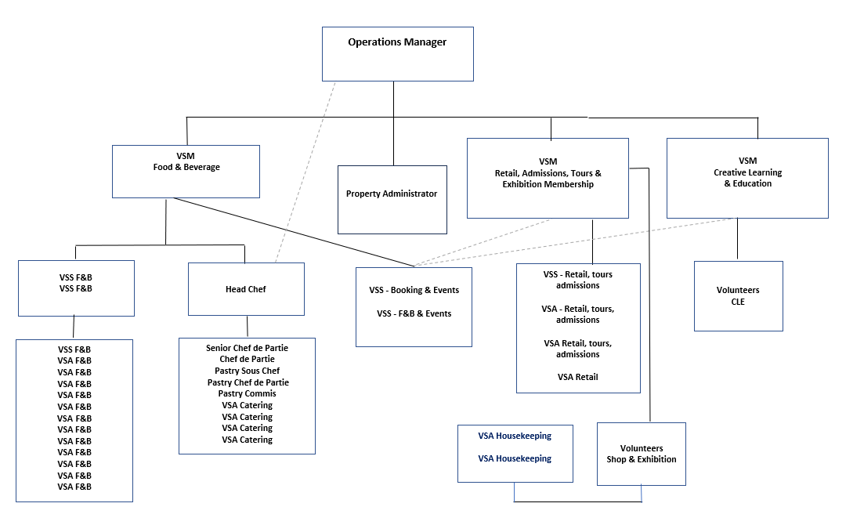

SCOPE OF THE ROLE

Scale
To lead by example and to take responsibility for a highly motivated team in delivering an exceptional hospitality and heritage visitor experience.

People Management
- Line Management of a team of permanent and seasonal Visitor Service Assistants and volunteers
- Manage and motivate all hospitality team members to deliver on a daily basis
- Will work closely with other property colleagues and will have interaction with other advisory colleagues based in other locations and departments across NTS.
Will have frequent interaction with suppliers and contractors

Financial Management
The Operations Manager is the overall budget holder, but the Visitor Services Supervisor has devolved responsibility for the day-to-day financial administration and policy adherence at the Property, including
- Ensuring the completion of the daily Cash/till reconciliation and reporting following the Trust’s policies and processes.
- Controlling staff costs in line with performance
- Contribute to achieving sales targets and membership recruitment targets
- Promote upselling and conversion between departments
- Management of month end stock takes
- Actively feedback visitor comments to line managers to improve offer, service and operations

Health & Safety, Food Safety, the Environment
- Ensuring that the operation meets statutory requirements of Health and Safety, Food Safety and Environmental legislations and procedures.
- Ensuring Allergen legislation adhered to, with up-to-date allergen information maintained.
- Recording and reporting all accidents within the location, adhering to location and company procedures
- Establishing and maintaining location cleaning schedules
- Ensuring that all Trust procedures and work instructions are fully understood and practiced by all employees
- Promoting and encouraging environmental improvement initiatives as appropriate within the business

Tools/ equipment/ systems
- Will regularly use a wide range of ICT equipment including two-way radio, mobile phone, land-line phone, email, scanner, laptop/PC, printer etc.
- EPOS till system to place, process and print orders
- Will use catering equipment including coffee machines, dishwashers, and some cooking equipment.
- Use of cleaning chemicals during shift
- Pass lifts
- Clock in/clock out on payroll app

Key performance indicators and targets
- Food & beverage and membership sales targets are met or exceed budget
- Staffing costs are kept in line with the budget
- Systems of recording all up to date: including allergens, COSSH, cleaning records, stock take and wastage.
- Mystery Visit results and Visitor feedback reviews
- Recruitment; (induction; development; performance reviews, sickness management) are carried out. To ensure visitor services employees and volunteers are trained and equipped to fulfill their roles to the standards required and that they feel valued, respected and supported.

The Key Responsibilities, Scope of Job, and Required Qualifications, Skills, Experience & Knowledge reflect the requirements of the job at the time of issue. The Trust reserves the right to amend these with appropriate consultation and/or request the post-holder to undertake any activities that it believes to be reasonable within the broad scope of the job or his/her general abilities.

HOW TO APPLY

Interested applicants should forward their Curriculum Vitae (CV) or an Application Form to the People Services Department (Applications) by email via workforus@nts.org.uk.

Please ensure your CV includes your full name and contact details, the CV file sent to us should be titled your first initial and surname. When submitting your CV please state the position and job location of the vacancy you are applying for in the subject title or body of your email: For example, "VSS Food & Beverage – Mackintosh Tearooms"

