 | Job Description | Oct 2025
Role: Conservation Maintenance Surveyor | Region / Department: Conservation & Policy
Reports to: National Maintenance Lead | Pay Band: Grade 5 Lower - £40,707 - £44,847 Per Annum
Location: Highland and Island region, but potentially flexible on an informal basis to work at some times from home following our Hybrid Working arrangements. | Type of Contract: Full-Time, Permanent
40hrs Per Week, generally working Monday to Friday during normal business hours.

CONTEXT

The National Trust for Scotland is an independent charity set up in 1931 for the preservation and conservation of natural and human heritage significant to Scotland and the world. The Trust has gone on to become Scotland's largest membership organisation and a leader in conserving and promoting the nation's treasured places and collections so they can be enjoyed by present and future generations. The Trust’s new 10 Year Strategy: Nature, Beauty and Heritage for Everyone has recently been launched with a strong focus on caring for Scotland’s special places through best practice in conservation.

Visit: https://www.nts.org.uk/our-work/our-strategy

The Trust is organised across 4 Regions:

North East: Regional Office – Crathes Castle
Highlands & Islands: Regional Office – Balnain House, Inverness
Edinburgh & East: Regional Office – Newhailes House
South West: Regional Offices – Culzean Castle (main), Greenbank House (northern hub)

Each Regional General Manager has operational responsibility through Property Staff for maintaining built assets and ensuring statutory compliance within their Region. The Central Buildings Team operates through a consultancy model with dedicated resource in each Region.

The role of the Buildings Team is to provide NTS with professional and technical services in support of building conservation, maintenance and capital building projects across the Trust’s built estate. Each Region is currently supported by a dedicated Building Surveyor (or Architect) who ensures that NTS delivers best practice in building conservation and maintenance.

You will be assigned to the Highlands & Islands region, joining the Regional Building Surveyor and providing a leadership role for building maintenance activity within the region. You will also assist the Building Surveyor with larger project delivery. Your key day to day contacts will be the Regional Building Surveyor, Operations, Maintenance and Property staff.

The Buildings Team is a national asset of the NTS and operates as a single team. Individuals will sometimes be required to operate beyond their ‘home’ Region or to provide specialist advice to other team members. In exceptional circumstances, individuals may be asked to relocate temporarily to deal with a particular situation e.g. as part of disaster recovery efforts. The role will also require occasional work outside core hours to deal with emergency or unplanned situations

JOB PURPOSE

This job will support the National Trust for Scotland Strategy by contributing to improving the condition of our buildings, delivering best practice in built heritage conservation and maintenance management, and supporting the safe operation of our sites.

Reporting directly to the National Maintenance Lead you will be responsible for supporting and undertaking the planning and delivery of sensitive conservation, maintenance and repair to NTS buildings and advising property operations teams on all aspects of buildings care. You will assist operations staff to maintain public access to sites and buildings during essential building work.

KEY RESPONSIBILITIES AND ACCOUNTABILITIES

Maintenance Management:

Reporting to the NTS National Maintenance Lead:

- You will be responsible for developing Regional and Property Maintenance Plans on a standard framework, for agreement between the National Maintenance Lead and Operational Manager. Plans will include details of works required, timescales, budgets and delivery methodology (e.g. internal delivery or outsourced).
- You will undertake building inspections and surveys in your Region and commissioning externally produced condition and specialist surveys in support of the Property Maintenance Plan or because of an emergency or unplanned circumstances. Surveys may be requested by others, or the requirement may be identified by you in the course of your work and will be subject to agreement with the National Maintenance Lead and Regional Operations Teams.
- Monitor Property Plans and report progress to operational teams and the National Maintenance Lead making recommendations for adjustment or improvement if required.
- Monitor the quality of works executed and identify any deviation from the required and provide regular reports and recommendations to operational teams and National Maintenance Lead.
- Respond to requests from operational staff for support in managing reactive and emergency maintenance situations.
- Assist operational teams with efficient procurement and delivery of building compliance activities in accordance with the Trust’s policy.
- Support operational teams, and Trust central teams, including NTS Holidays, Food and Beverage, ICT, Health and Safety and the Trust’s Estates Surveyors with provision of professional services.

Building Conservation & Repair:

- Collaborate with the Regional Building Surveyor and operational teams, to plan future capital works alongside planned preventative maintenance and ongoing operations of sites.
- For larger and more complex projects provide support to the Regional Building Surveyor including undertaking site inspections to verify quality of works underway complies with specifications.
- For smaller capital maintenance projects, you will:
  - Specify and produce tender packages with the support of the Regional Building Surveyor and Trust Procurement Team.
  - Manage procurement in accordance with Trust procedures and oversee works on site to ensure that all works are deliver best value and are undertaken safely and to the highest standard of workmanship and conservation.
  - Lead and contribute to teams of internal and external specialists and contractors in the development of programmes and packages of work appropriate to each situation and building.

Statutory & Health & Safety:

- Ensure that all works under your control are planned and delivered in accordance with statutory, contractual and health and safety requirements. This includes but is not limited to internal policies, Planning, Listed Building and Building Warrant, H&S regulation including CDM, contractual terms, environmental monitoring and compliance, DDA and insurers’ requirements. You will have access to advice from other internal specialists in delivering this requirement.

REQUIRED QUALIFICATIONS, SKILLS, EXPERIENCE & KNOWLEDGE

Qualifications

You will have experience of working in maintenance planning and management or demonstrable understanding of maintenance management processes e.g. through similar experience or trade background or experience of working in a role caring for historic buildings.

Essential

- A degree level or equivalent qualification(s) in construction, surveying, facilities or maintenance management, architecture or built heritage conservation.
- 5 years' experience of working in building maintenance management or the care of historic buildings.
- A valid UK driving license and access to a vehicle that you can use for work.

Desirable

- Practical or academic qualifications related to traditional buildings skills or built heritage conservation.
- Practical or academic qualifications related to maintenance or facilities management.
- A current CSCS card at a supervisory level.

Experience

Essential

- Experience of developing and leading planned preventative maintenance programmes.
- Understanding of surveying practices and procedures, traditional building construction, pathology and survey techniques.
- Understanding of the application of relevant legislation and regulation.
- A high level of Health & Safety awareness.
- Experience of supervising consultants and contractors.
- Experience of managing competitive procurement processes.
- The ability to lead and work in multi-disciplined teams, respecting the expertise of others and actively promoting strong working relationships with colleagues.
- Excellent communication skills with the ability to connect easily with technical and non-technical audiences.
- Commitment to providing a professional, customer focused service.
- Initiative and the ability to prioritise and manage a busy workload.
- A commitment to continual improvement, professional and skills development.
- Commitment to the aims and objectives of the National Trust for Scotland.
- Willingness to travel for work.

Desirable

- Experience of maintenance of a diverse built portfolio.
- Experience of working with historic buildings.
- Experience of working with standard forms of contract, including undertaking contract administration.
- Familiarity with Microsoft Suite, Office 365 including SharePoint.
- Awareness of climate change/sustainability issues in relation to historic buildings.
- Use of AutoCAD, Revit or similar.

DIMENSIONS AND SCOPE OF JOB

Scale

This role is within the National Trust for Scotland Buildings Team. You will be responsible for providing professional surveying services to the Highlands & Islands National Trust for Scotland region in support of the best practice conservation maintenance of our built estate.
You will be part of a professional, national Buildings Team under the management of the Head of Building Conservation:

- You will work closely with the Regional Building Surveyor who is a specialist in built heritage conservation adding your expertise in maintenance management to develop a tailored conservation maintenance service for your region, within the National Maintenance Framework.
- You will provide support to operational teams in the delivery of their responsibilities, which relate to the day-to-day maintenance and operation of our buildings,
- You will support the Regional Building Surveyor on capital repair and conservation projects, assisting with administration and supervision of projects.
- You will assist in ensuring that all building operations are undertaken safely in compliance with relevant Health and Safety regulation including CDM15.

People Management

The Buildings Team is comprised as shown below, this role has no direct reports, key collaboration is with the Regional Building Surveyor and Business Manager Buildings.

All posts are overseen and managed by the Head of Building Conservation, however you will be directly line managed by the National Maintenance Lead.

Finance Management

You are not a budget holder but have responsibility for obtaining cost estimates for proposed works, making recommendations to budget holders on acceptance or rejection of those costs and monitoring and reporting on expenditure against purchase orders recommending payments to budget holders against works delivered.

You will also assist in obtaining and estimating costs for inclusion in future budget setting.

Tools / equipment / systems

No specialist tools, equipment or systems required for this role. PPE as required will be provided.

Example key performance indicators and targets

- This role will contribute to the delivery of the Conservation Performance Indicator (CPI).
- This role will contribute to the delivery of the delivery of objectives, milestones and major projects contained in the Trust’s Operational Plan:

Buildings Team Organisational Chart

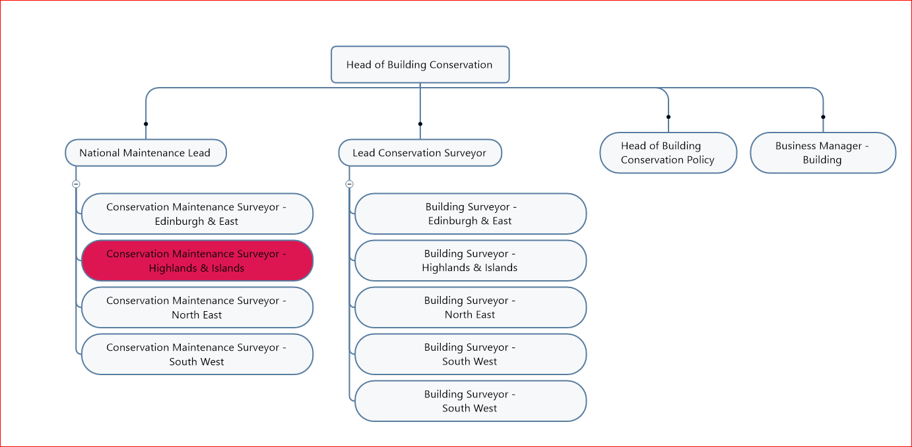

The Purpose, Context, Key Responsibilities, and Person Specification reflect the requirements of the job at the time of issue. The Trust reserves the right to amend these with appropriate consultation and/or request the post-holder to undertake any activities that it believes to be reasonable within the broad scope of the job or his/her general abilities.

How to Apply
Interested applicants should forward their Curriculum Vitae (CV) or an Application Form to the People Services Department (Applications) by email via workforus@nts.org.uk by Sunday 26th October 2025.

Please ensure your CV includes your full name and contact details, the CV file sent to us should be titled your first initial and surname. When submitting your CV please state the position and job location of the vacancy you are applying for in the subject title or body of your email: For example, "Conservation Maintenance Surveyor – NTS."

NATIONAL TRUST FOR SCOTLAND

CONSERVATION MAINTENANCE SURVEYOR

(Highlands & Islands)

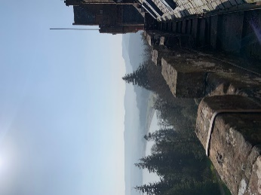 | 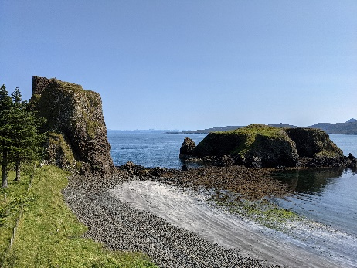 | 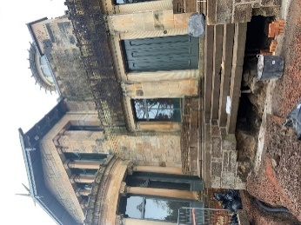 | 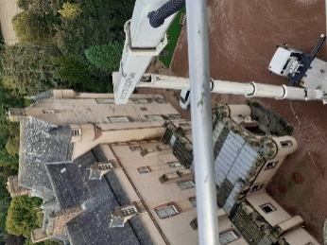

Imagine working here!

The National Trust for Scotland is looking for a strong team player who is committed to conserving and sharing Scotland’s heritage. Join the NTS Building Team and you will work with Scotland’s largest and most diverse portfolio of historic buildings and structures. This is an exciting time for the Trust as we have a 10-year Strategy: Nature, Beauty and Heritage for Everyone https://www.nts.org.uk/our-work/our-strategy with a strong focus on caring for Scotland’s special places through best practice in conservation.

The role

We are seeking a Maintenance Surveyor to support our work. You will be embedded in the Highlands and Islands regional team. As the regional building maintenance specialist, you will work closely with the regional Building Surveyor to advise and support Operations Teams, putting the Trust’s Conservation Principles into practice through focusing on planned and reactive maintenance of all built structures.

In this role, you will be instrumental in shaping the way the Trust manages the maintenance of its buildings, helping to build maintenance plans for each building and dealing with backlog maintenance projects.

Where you will work

You will be based at our Highlands regional office (Inverness), but most of your work will be site based at properties. You will need your own transport and should expect to be away from home overnight on some occasions

Who are we looking for

We are looking for exceptional people to care for our exceptional buildings. You will have a good understanding of building maintenance planning and delivery, traditional building construction, pathology and survey techniques and experience of organising and overseeing works to buildings. Your ability to communicate effectively, building strong collaborative relationships with peers, internal clients and other stakeholders, is as equally important as your technical knowledge.

Beyond this we are interested in speaking to people from a range of professional building and trade backgrounds, and we would be happy to advise you whether your qualifications suit our needs. Any enquiries should be forwarded to: workforus@nts.org.uk

What we offer

Our close nit Buildings Team has a challenging job where no two days are the same but where we firmly believe that we can make a real difference to the future of Scotland’s built heritage. This is an opportunity to work with some of Scotland’s top experts in heritage management across natural, built and cultural heritage as NTS embarks on a big vision: Nature, Beauty and Heritage for Everyone.

We offer a competitive salary, 30 days annual leave per annum (plus up to 7 Trust days during the Christmas holiday season), enrolment in one of the Trust’s pension scheme and a benefits package including free entry to all National Trust for Scotland properties and discount at NTS shops and cafes.

